From the Flight Navigation Display, click Create Graphic  
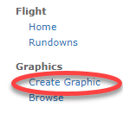

The Instrument Panel is broken down into four choices for template selection.  
1. Theme – News, Sports, Shows, etc.  
2. Type – Lower Third, Double Box, Full screens, etc.  
3. Template – Breaking, Web, Quote, Mugshot, 1x1 Box, OTS Left, etc.  
4. Style – 1-Line, 2-Line, Banner, etc.

From the Flight Deck, choose a Theme  
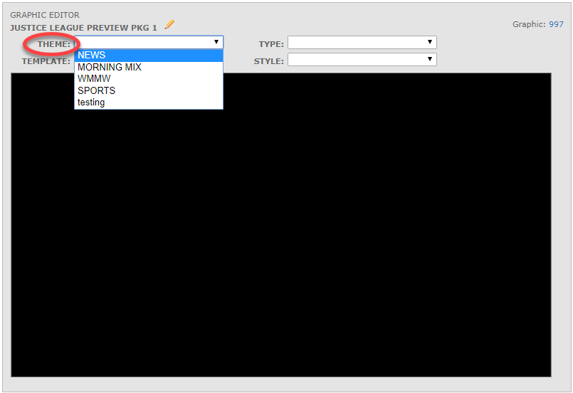

Choose a Type  
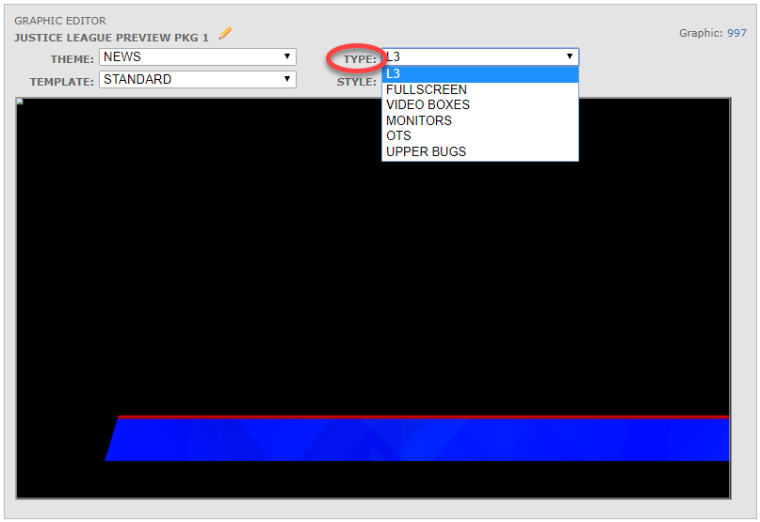

Then choose a Template  
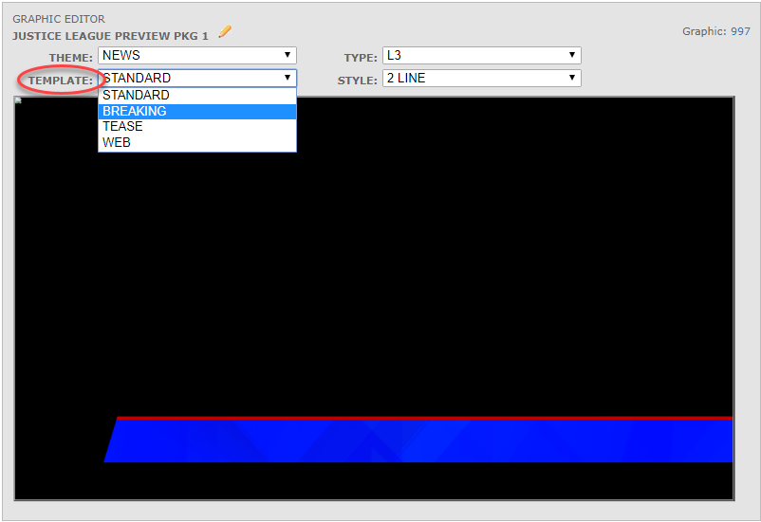

Finally, choose a Style  
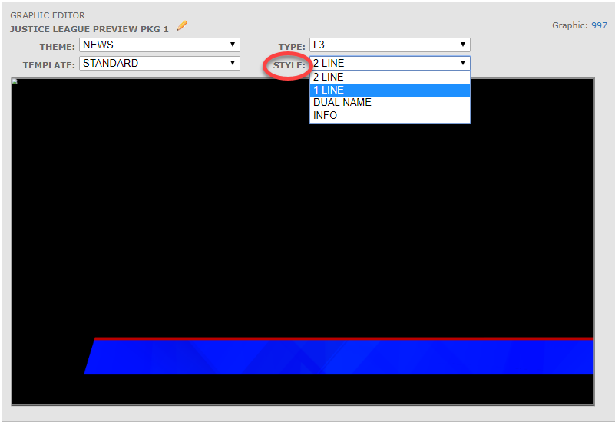

Begin typing in the fields. The Flight Deck will show a live preview as text is entered.   
Note: If the text passes the field width, the text tyed in will not show up until the Save Button is clicked.   
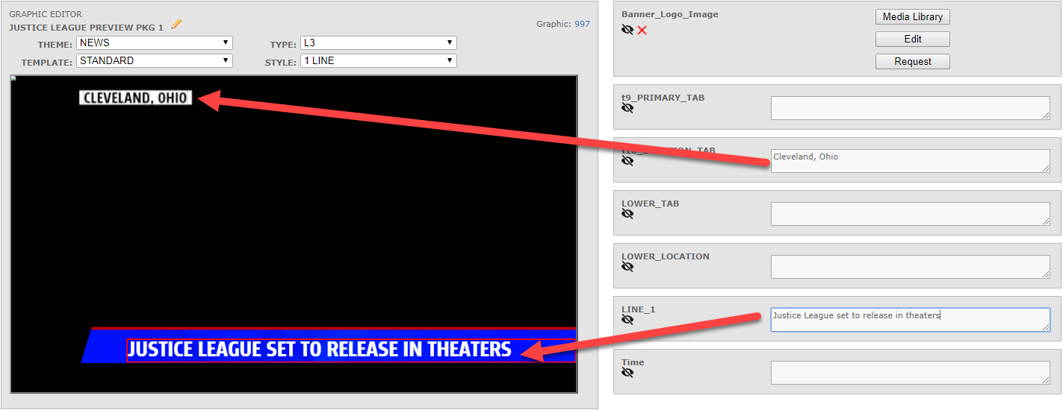

Note: the selected field will outline in red  
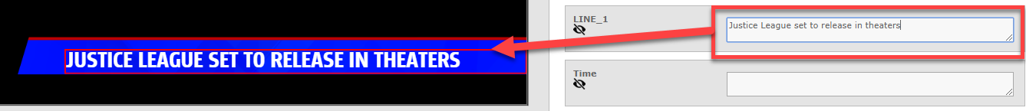

Click Save  
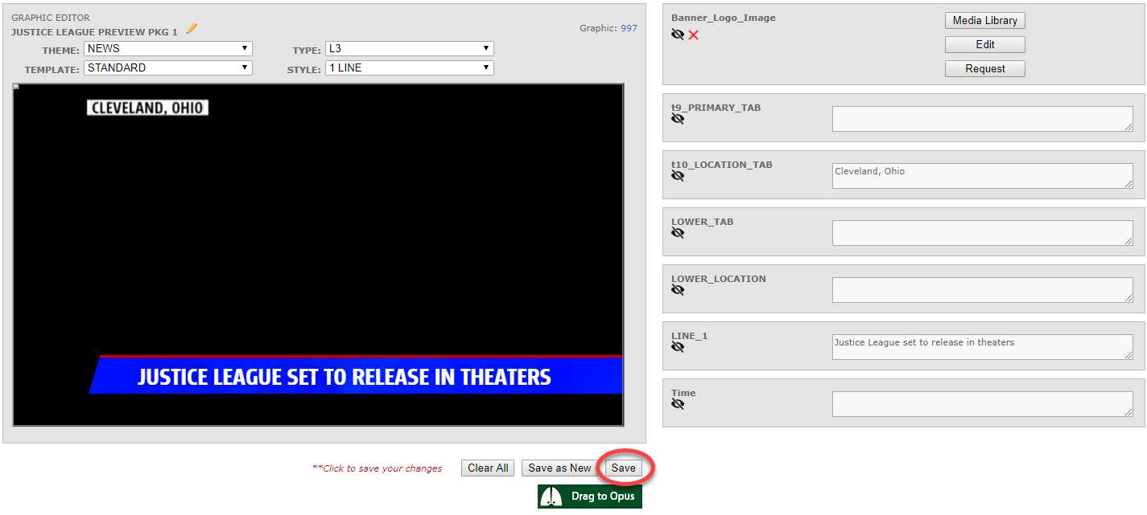

The Flight graphic will refresh and run  
